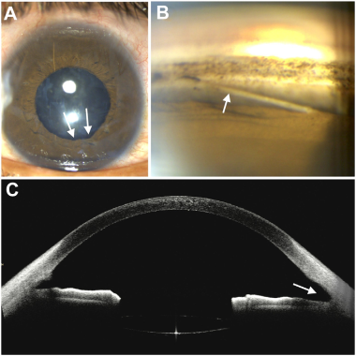

A 24-year-old man presented 15 days after blunt trauma to his left eye (OS) with a tennis ball. Intraocular pressure (IOP) was 28 mmHgOS, with sphincter tears (A, arrow) along inferior pupillary margin. Gonioscopy revealed detachment of the scleral spur (B, arrow) from itsroot at the scleral roll, with posterior iris displacement. Anterior-segment OCT revealed relative deepening of the inferior angle (C, arrow)versus superior angle. Based on the provided images and clinical description please make an ophthalmic diagnosis for this patient. And output the diagnostic conclusions only.

**Ophthalmic diagnosis: Traumatic angle recession**